Asteroid Game Manual

To run the game just run the main method of the “Game” class.

The aim of the game is to destroy all asteroids and objects to move up the levels and earn a new high score, but you must be careful as you only have a certain number of lives and hit point so you must evade bullets and asteroids.

**Controls**

W/UP_ARROW – thrust forward

A/LEFT_ARROW – turn left

D/RIGHT_ARROW – turn right

SPACEBAR – fire guns

ENTER – pause game

**Visuals**

Backgrounds are randomly generated and there is a chance that a background prop will spawn with the background, these do not affect gameplay.

The player ship looks like this:

Whereas the enemy ships look like this:

Player bullets are blue and enemy bullets are red.

When one or both of the following icons are in the top left corner, you the player are buffed with either invincibility or double damage (see mechanics for explanation).

Multiple stats are shown at the bottom of the screen, like this:

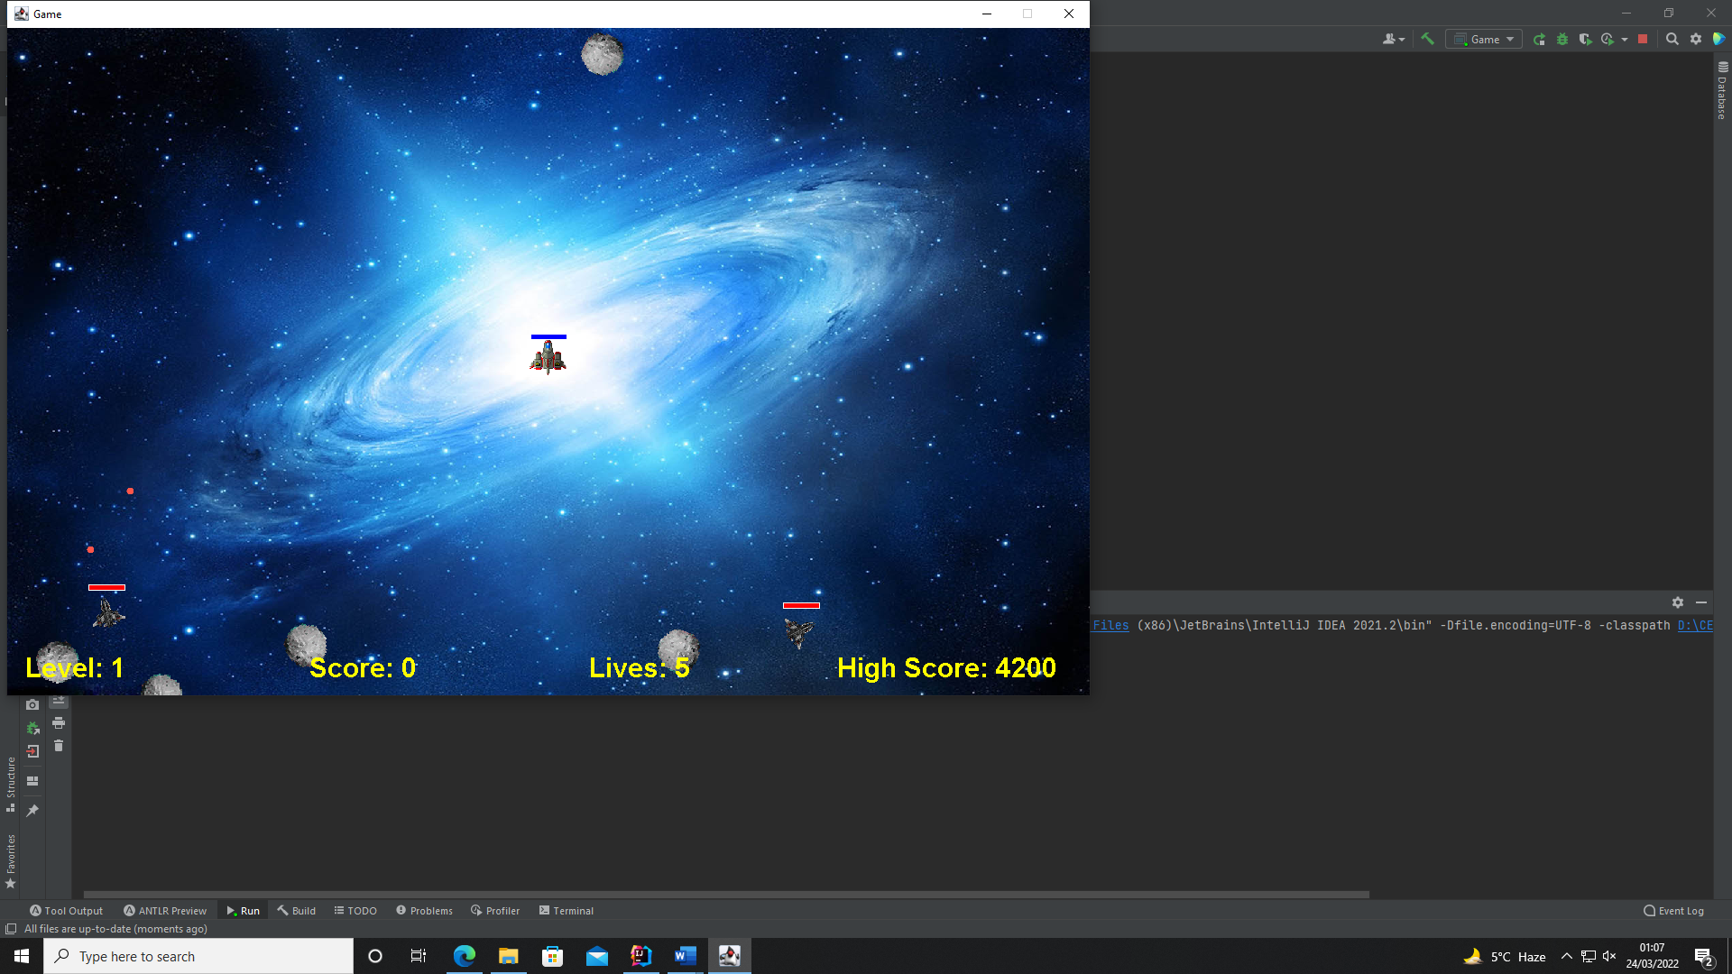

**Mechanics**

Player

The player ship has 2 hit point, and it could have a rechargeable energy shield, shown by the blue bar. This shield is only allowed in the normal difficulty and has a 5 second recharge time.

Enemy types

There are two types of enemies which have the same appearance. One of these moves and shoots randomly, the other is very unpredictable, moves fast and tries to target the player. Enemies have 2 hit points

Power ups

When an enemy dies, there is a chance to spawn a power up. These being health or double damage, shown here:

When the health power up is picked up, the player is healed for 1 hit point. However, when a double damage power up is picked up, the player gains the double damage buff and can now kill enemies in one hit. This lasts 20 seconds.

After being spawned, power ups only last for 5 seconds, so pick them up quick before they are gone.

Levels

After all enemies and asteroids are destroyed, you advance to the next level, which get harder as you progress.

If all your hit points are gone, you lose a life and start the level from the beginning.

**Menus**

Start menu

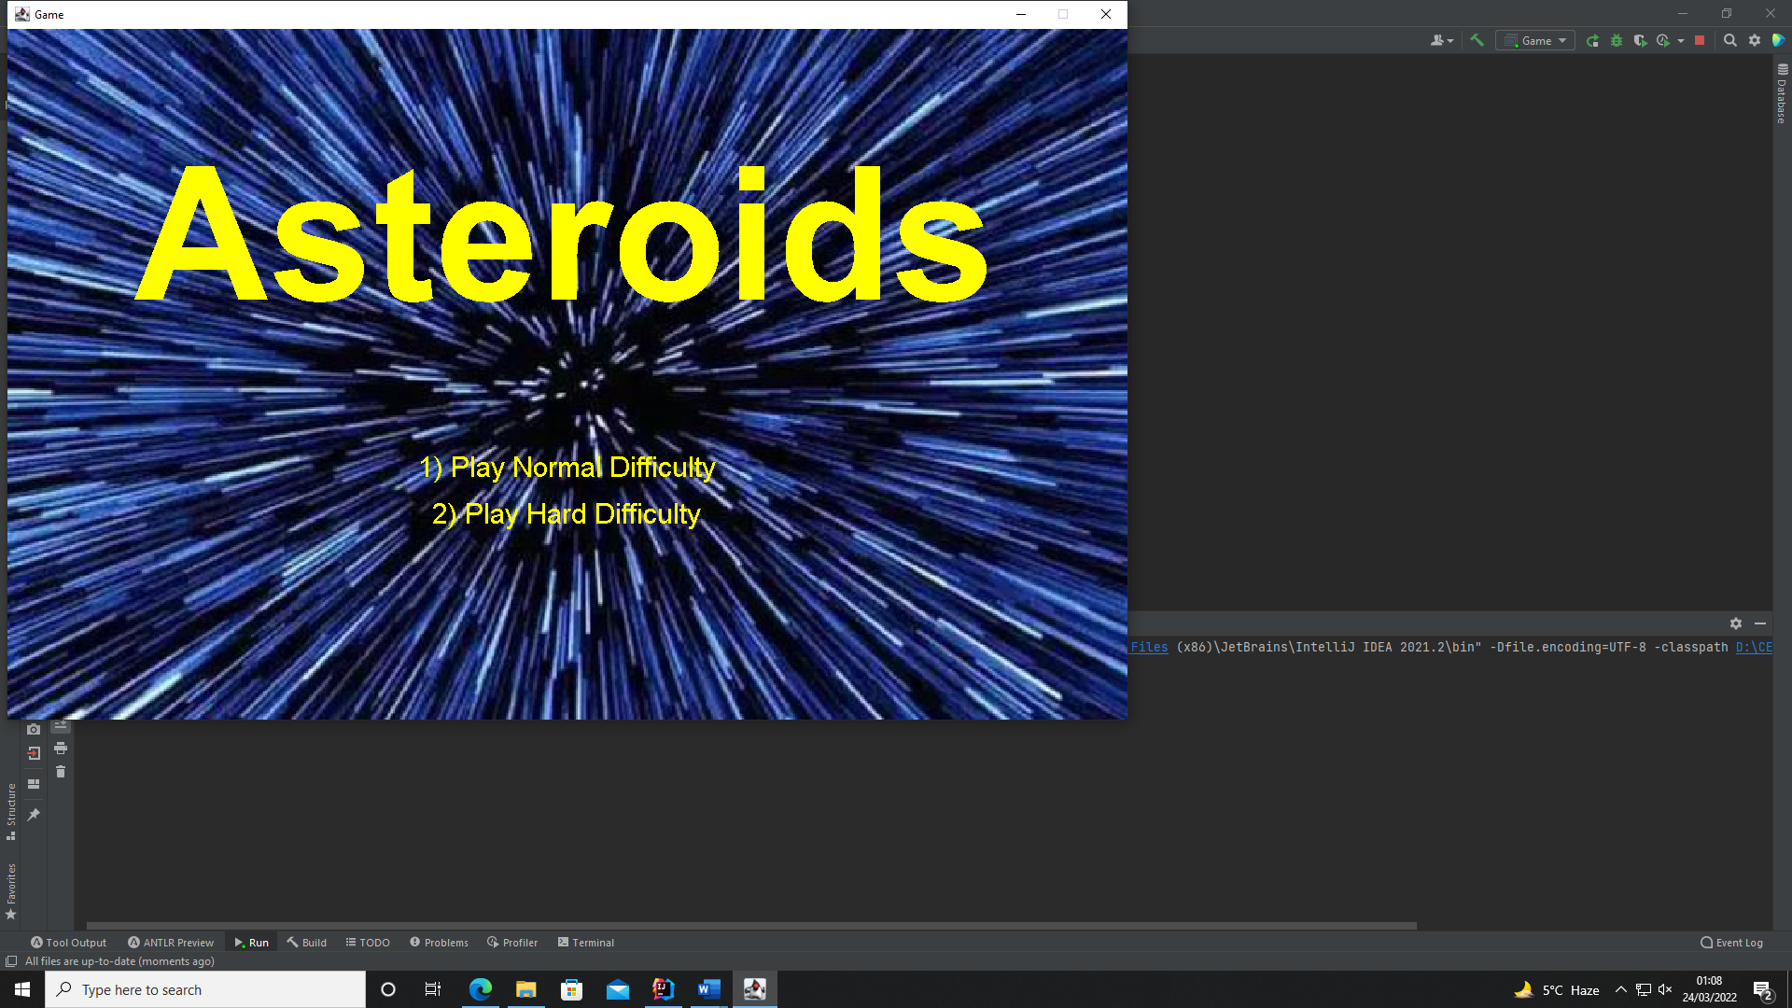

Press 1 to start the game on normal difficulty which gives the player ship a rechargeable energy shield.

Press 2 to start the game on hard difficulty which doesn’t allow this energy shield.

Pause menu

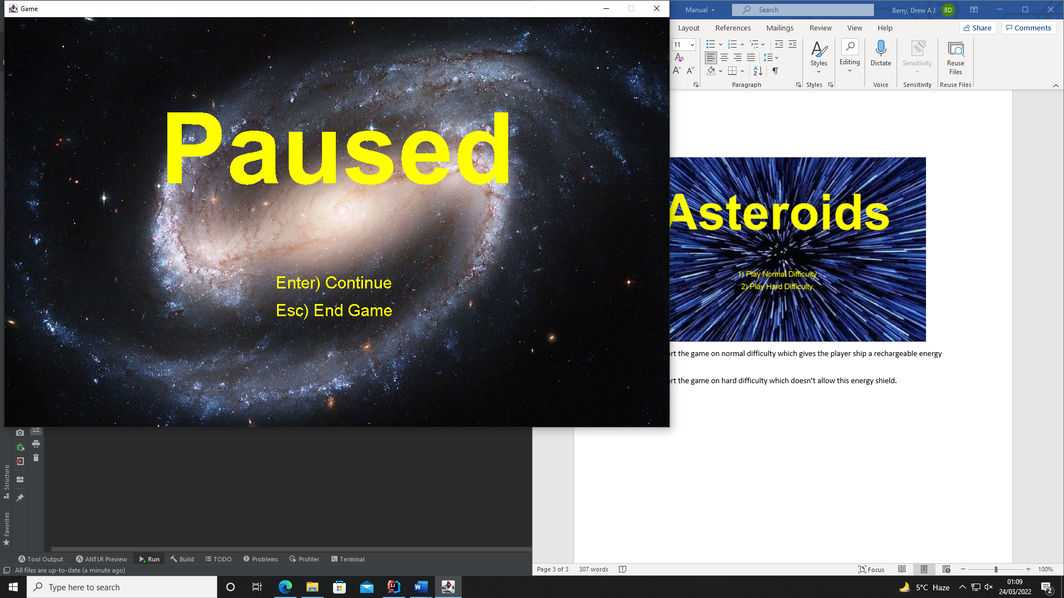

Press ENTER to continue playing the game

Press ESC to end the game early and go to the game over menu.

Game over menu

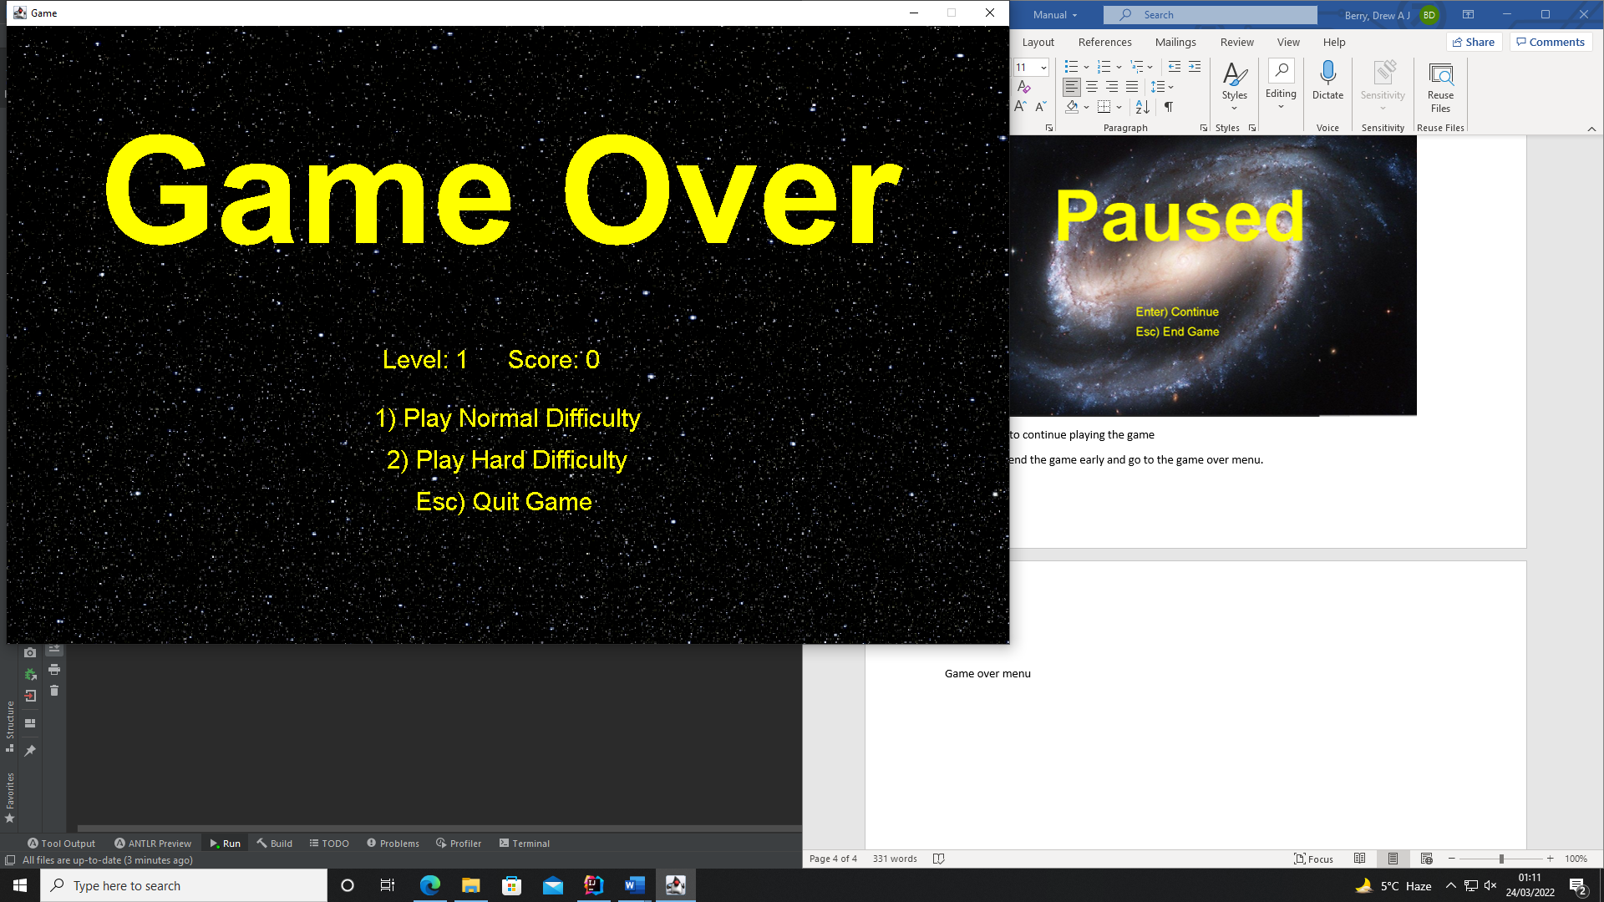

Press 1 to start the game on normal difficulty.

Press 2 to start the game on hard difficulty.

Press ESC to quit the game.